SPORTSPLEX MLK Day
SOCCER TOURNAMENT
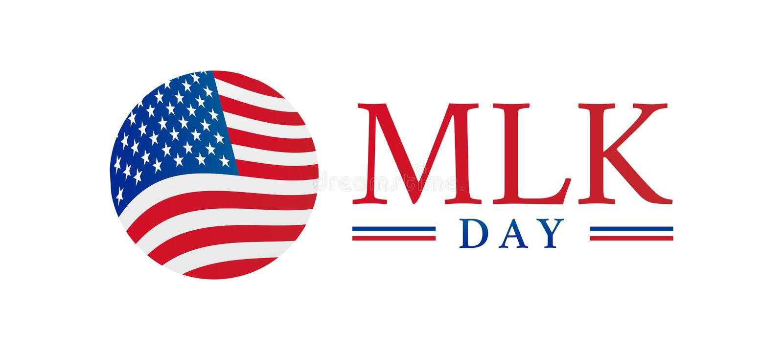
- 30 Minute games, 3 games guaranteed!!
- Entrance Fee- $225 per team
  - includes referee fees
- Prize For Champions
- Maximum roster of 18 players
- Rules posted on our website
- All age groups follow the NYSW age matrix
- Register on our website: http://www.sportsplexinc.com/

- Early Bird Deadline (Save $25 Off Reg Fee): Monday, January 1, 2024
- Registration Deadline: Monday, January 8, 2024
Tournament Date
Monday 01/15/2024:
8:00am – 4:00pm
Divisions:
- Girls:
  - U10 – 8v8
  - U12 – 8v8
  - U14 – 8v8
  - U16 – 7v7

**Limited Space Available

