End of the Season Party
Join us for two hours of fun on Saturday (4/29) filled with inflatable obstacle courses and inflatable games provided by our Friends over at Bounce USA. What better way to end the indoor season than racing your teammates through the inflatable obstacle courses or testing your skills with the inflatable All In One Sports Center and Inflatable Axe Throwing zone!
Team Package Fee: $300
- Includes 2 hours of play
- 20 participation bracelets
  - any additional bracelets will be $15
  - Food & Beverage Packages also available
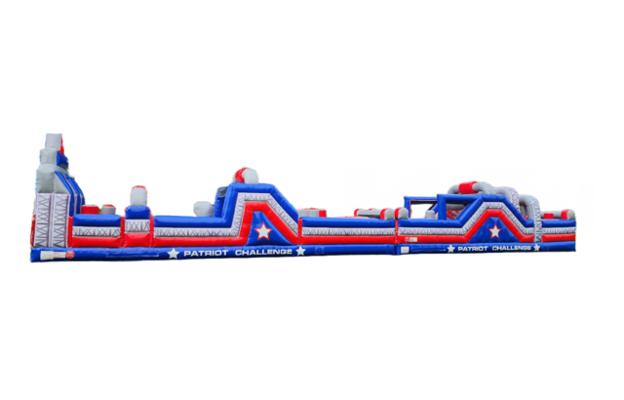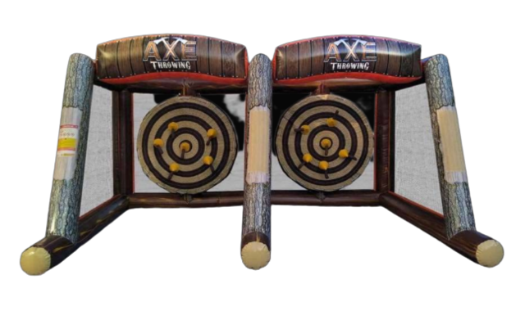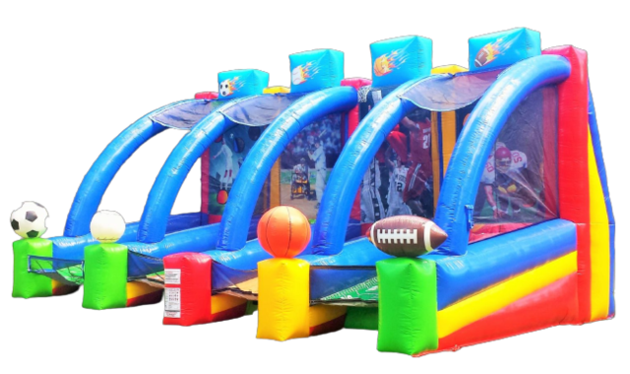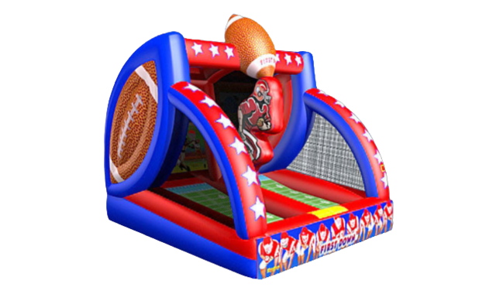
Please email us @ SportsplexSoccerDirector@gmail.com with any questions or to reserve your team’s spot.

