SPORTSPLEX BIRTHDAY PARTIES

**Sportsplex Simulator Package  
*GC Hawk Technology allows for golf or soccer gameplay\***

Test your skills in foot golf, carnival games, driving range, or one of many virtual golf courses!  
  
**Simulator Party Package:** $300  
Included in the package:

* 2.5 hours of exclusive access to both simulators and party room
* 3 Large Pizzas (12 slices each)
* 3 Pitchers of Pop
* Party Host

*Additional Food and Beverage can be added.

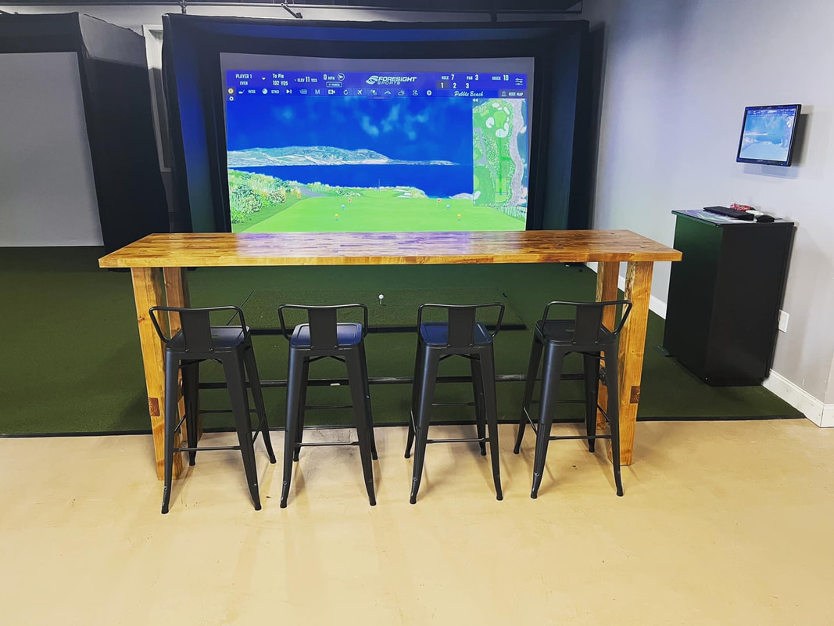

**Sportsplex Field Packages**

**Field Party Package w/ Host:** $250  
Included in the package:

* 1 hour of exclusive access to our turf practice field
* 2.5 hours of exclusive access to party room
* 3 Large Pizzas (12 slices each)
* 3 Pitchers of Pop
* Party Host

*Additional Food and Beverage can be added.  
  
​  
**Field Party Package:** $200  
Included in the package:

* 1 hour of exclusive access to our turf practice field
* 2.5 hours of exclusive access to party room
* 3 Large Pizzas (12 slices each)
* 3 Pitchers of Pop

*Additional Food and Beverage can be added.

Limited space available- book ASAP

Over the phone by calling @ **(716) 694-8877**

Or in person at the front desk – Or emailing SportsplexSoccerDirector@gmail.com

**$50.00 non-refundable deposit required at booking.**